West, North and East Cumbria Success Regime
Rosehill, 4 Wavell Drive,
Rosehill Industrial Estate, Cumbria

Ms Sue Stevenson and the Venerable Richard Pratt,
Co-Chairs, Public Consultation Process Stakeholder Advisory Group

1 November 2016

Dear Sue and Richard,

Thank you for forwarding to me the minutes of the latest meeting of the Public Consultation Process Stakeholder Advisory Group (PCPSAG) held on 18th October 2016.

I note that these minutes contain seven recommendations (numbers 20 – 26 in the master list) all of which require action by the NHS.

I can confirm that all of these recommendations are accepted. I further confirm that we will endeavour to ensure they are all acted upon.

May I also take this opportunity to thank you both – and the members of the Stakeholder Advisory Group – for your powerful statement against racism and abuse. It is sad that the victim of the racist attack now feels so intimidated that he is somewhat disinclined to speak in public in West Cumbria about the consultation but I believe your statement was both right and timely.

Yours sincerely,

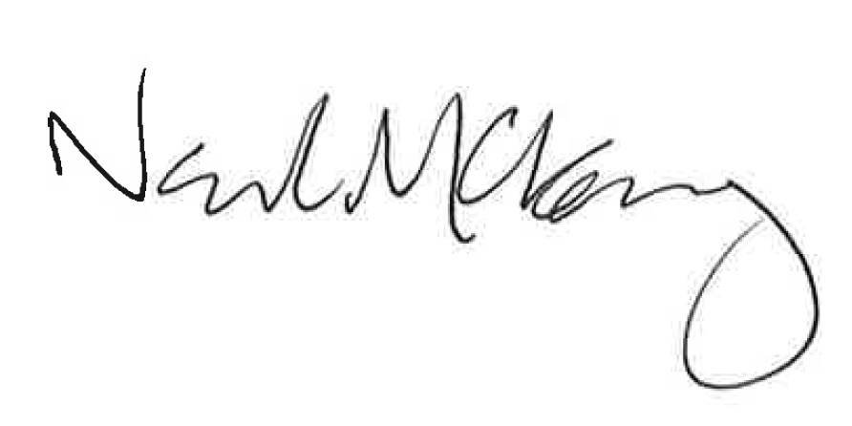
Sir Neil McKay
Chair of the Programme Board
West, North and East Cumbria Success Regime

